Additional
Flare Incident
Guidance

A supplement to Appendix India of the Coast Guard Addendum to the National Search and Rescue Manual

National Search and Rescue School

Red and orange flares are an internationally recognized maritime distress signal and are required equipment for most U.S. vessels that operate on open waters. On average, Coast Guard crews respond to hundreds of flare sightings every year. Yet, only a small fraction of the searches initiated actually locate a vessel in distress. There are several reasons for this. Difficulties in flare case prosecution occur in all five of the SAR stages.

Introduction
- Awareness. The typical reporting source of a flare sighting is a concerned citizen with little or no boating experience. In addition, natural and man-made occurrences are often mistaken to be flares and cause inadvertent activation of the SAR System.
- Initial Actions. It is often difficult to obtain an accurate report because of the variety of different types of flares, experience level of the reporting source, and ability the search planner to extract the necessary information to properly assess the situation.
- Planning. Planning a search for an unknown search object requires numerous assumptions to be made and becomes even more complicated with a lack of practical guidance on flare prosecution.
- Operations. Despite the credibility of the report and the SAR controller’s ability to develop an optimal plan, our crews can only respond to so many flare sightings that fail to locate the search objective before they become complacent and unmotivated.
- Mission Conclusion. Because of the uncertainties and assumptions involved in search planning, it is difficult, if not impossible, to adequately measure a search’s effectiveness. Furthermore, the requirements to conduct first light searches for unresolved flare searches vary between districts, causing inconsistent efforts Coast Guard wide.
The Coast Guard Addendum provides search planners with recommended procedures and guidance for flare case prosecution. This paper is intended to expand on some of the topics contained in the Coast Guard Addendum, and introduce some new ideas to help SAR Mission Coordinators through the five stages of a flare case.

The Coast Guard Addendum requires red and orange flare cases to be classified as distress unless available information indicates otherwise. Despite this requirement, we often process the case in the opposite manner. There is a tendency to automatically assume the sighting as “another false alarm” until there are other factors that can be tied to the sighting, such as an overdue report or uncorrelated mayday. This is a hazardous thought pattern. You need to remain proactive with each and every sighting, regardless of the high number of unresolved cases.

Awareness and Initial Actions
Typically, a flare sighting is reported by a concerned citizen from shore who has never seen a flare before and is not certain if what was seen was actually a flare. To complicate matters, flares are often confused with meteor showers or a falling star, military flight operations, other aircraft making an accent or decent (most often with landing lights on), a distant vessel with deck lights energized, and even aids to navigation beacons.

Meteor Showers and Shooting Stars
Meteors, also known as “shooting stars”, are streaks of light that suddenly appear in the sky when dust particles from outer space evaporate in the earth’s upper atmosphere. Sometimes it’s hard for even an experienced seaman to distinguish between a meteor and a flare. Before assuming a meteor was mistaken as a flare, you need to have an understanding of what meteors are and what they look like.
Meteor showers occur when the earth passes through the debris field of a comet. This “space trash” burns up as it moves through the atmosphere, leaving behind several “wakes” of light. Most wakes last from one to ten seconds. Some brighter meteors can leave behind a “persistent train” that can last for up to 30 minutes. Meteor wakes are normally white, but may appear in nearly every color of the spectrum.
While a sporadic meteor can appear anytime, most meteor showers occur on a regular basis every year. These showers are named after the nearest constellation from where they seem to originate. The origin is also referred to as the shower’s radiant. The following table provides information on major meteor shower activities and can be used to help correlate a suspected false flare sighting with a meteor.
Name/  Radiant | Annual Occurrence | Peak  Occurrence | Average Per Hour
Quandranids | 28 Dec –7 Jan | 3-4 Jan | 45 – 200 +
Lyrids | 16-25 Apr | 21-22 Apr | 100 +
Eta Aquarids | 21 Apr – 12 May | 5 May | 20 +
Southern Delta Aquarids | 14 Jul – 18 Aug | 15 – 20 May | 10 +
Northern Delta Aquarids | 16 Jul – 10 Sep | 13 Aug | 10 +
Perseids | 23 Jul – 22 Aug | 12-13 Aug | 80 +
Southern Iota Aquarids | 1 Jul – 18 Sep | 6 Aug | 8 +
Northern Iota Aquarids | 11 Aug – 10 Sep | 25 Aug | 10 +
Alpha Capricornids | 15 Jul – 11 Sep | 1 Aug | 14 +
Orionids | 15 –29 Oct | 21 Oct | 20 +
Leonids | 14 – 20 Nov | 17 Nov | 15 +
Geminids | 6 – 19 Dec | 13 – 14 Dec | 100 +
If you suspect a flare sighting report was actually a meteor shower, begin by correlating the bearing of the report with the meteor shower’s radiant. The American Meteor Society’s web site provides a useful Observer’s Guide that will tell you where a meteor shower’s radiant can be located. The radiant will be described in true degrees and declination above the horizon. Start by correlating the reported flare to a meteor by matching the direction and angle of elevation of the flare sighting with a meteor’s radiant and declination. The American Meteor Society’s web site address is http://comets.amsmeteors.org/meteors/calendar.html.
Matching the report’s bearing with a meteor shower’s radiant is not enough to assume the sighting was a meteor. During the interview, you need to connect other clues. Without putting words in the reporting source’s mouth, ask the caller to describe what they saw.
A meteor’s wake normally “streaks” across a portion of the sky in an apparent straight line, as opposed to a meteor or parachute flare’s vertical arch of trajectory. A meteor’s wake can appear at any angle above the horizon. Only flares launched very close to the observer will appear to rise more than 8 degrees above the horizon. Unlike a meteor or parachute flare, there is no “burst” or flame associated with a meteor sighting. Because meteors travel across hundreds of miles of sky at high altitudes, they can be seen at greater distances by multiple observers. Flares on the other hand, can only be seen by observers within the flare’s nominal range because of their limited height. Meteors require a relatively clear sky to be seen. If a sighting was observed in an overcast sky, it is not likely a meteor. During a meteor shower, the observer will normally witness several wakes track across the sky. Mariners have a limited number or flares available.
If you are reasonably certain the reporting source mistook a meteor shower as a flare, conclude your interview by asking if it is possible that what was seen could have actually been a shooting star. Some callers might become embarrassed or even defensive at this point. It’s important to reassure the caller that meteors are often confused with flares, and that the Coast Guard appreciates the caller’s effort none the less

Military Flight Operations
Military flight operations are often the source of flare sightings. Military aviators will deploy red or white flares during the course of a training mission. TO BE DEVELOPED.

Other Military Operations
The military frequently uses various pyrotechnic devices in various colors and combinations. A list of the various pyrotechnic signals and their meanings can be found in Appendix C to the National Search and Rescue Manual, vol. I.

Distant Vessels
Commercial fishing vessels and merchant vessels illuminate their decks with powerful deck lights when performing work on deck or while at anchor. These lights may appear reddish-orange in color and may be confused with a handheld flare. When a report is received where the origin appears to be near known commercial vessel traffic, try to establish communications with those vessel(s) through the Urgent Marine Information Broadcast (UMIB). If a vessel in the area answers, request the operator to turn the deck lights off and on while the reporting source remains on the phone to correlate the sighting with the vessel.

Aids to Navigation
Under limited visibility, a distant aid to navigation’s beacon may be reported as a distress signal. Ruling out a flare is as simple as asking the reporting source to describe exactly what is seen, including interval between sightings. If the sighting appears and disappears at regular timed intervals (without a rise and fall) that match the light characteristics of an aid on the line of bearing, it can be safely assumed that the origin is an aid to navigation.

Ascending and Descending Aircraft
Distant aircraft (beyond aural range) taking off or approaching a runway can often appear to be a flare. The airplane’s landing gear lights can appear similar to a flare’s trajectory as it flies near the airport. If the report plots near an airport’s approach pattern, consider calling the Air Traffic Control Center to correlate report with any aircraft in the vicinity. If an aircraft was present in the area, ask the reporting source if they might have confused the sighting with an aircraft.

Planning a search for a flare’s origin is difficult because of the unknown variables involved. How reliable was the reporting source? Was the person in distress using a parachute flare or meteor flare? Did the flare originate from the deck of a ship, boat, raft, or from a person in the water? These questions are impossible to answer with confidence and require you to make logical assumptions in the absence of any other correlating information.

Planning

Datum Area Development Process
The Coast Guard Addendum provides guidance on developing a search area for a flare based upon the reporting source’s position, type of flare, bearing, and minimum and maximum ranges. The process of determining a datum area for a flare involves the following steps:
- Plotting the reporting source’s position and a circle to reflect the reporting source’s probable position error.
- Plotting the flare’s line of bearing and lines on either side of the position error circle to reflect the probable bearing error. These sides form the flare’s “cone.”
- Determining and plotting the minimum and maximum ranges that the flare could have been seen along the line of bearing. The maximum range forms the top of the flare cone.
- Enclosing the resulting area between the minimum and maximum ranges along within the bearing’s error lines.
- Expanding the length and width of the area by an appropriate safety factor (1.1 for the first search) and drawing a second, larger rectangle around the first.

Using the USCG SAR TOOLS Flare Plotter
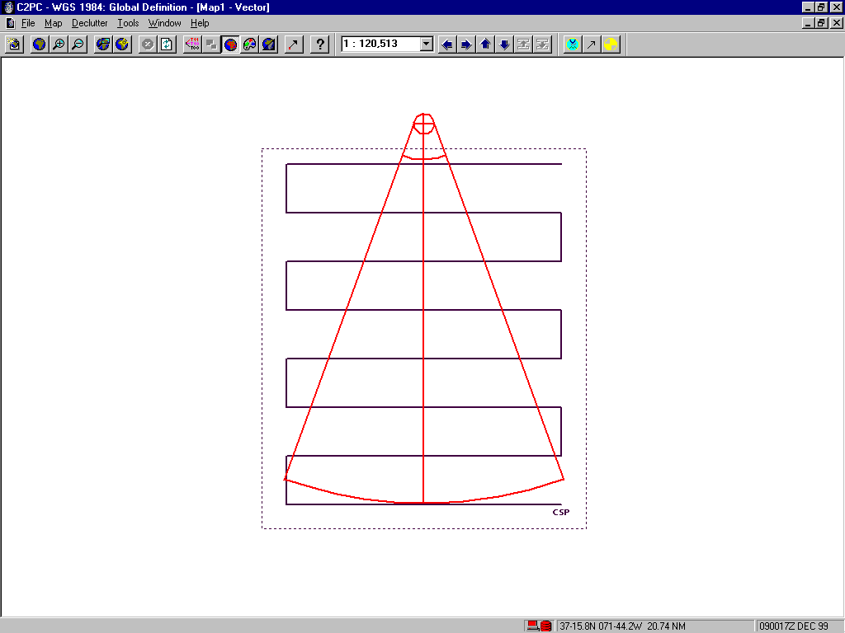
The USCG SAR TOOLS Flare Plotter uses the distance tables contained in Appendix India of the Coast Guard Addendum to develop the minimum and maximum ranges of the flare. The Flare Plotter also plots the line of bearing and the error lines to form the flare’s cone.
The illustration above illustrates SAR TOOLS’ flare plot and a creeping line search pattern using a 1.2 nautical mile track spacing for a NVG equipped helicopter.

Determining the Type of Flare
The type of flare observed has a major influence on the search area size. Since parachute flares reach greater altitudes, they can be seen at greater distances and thus will produce a large search area size. Section 3.B. of Appendix I of the Coast Guard Addendum describes the characteristics of flares commonly used to signal maritime distress. Not included in this section are the burn durations for Coast Guard approved flares. A flare’s burn duration can help differentiate the type of flare. The table below provides the minimum burn duration for Coast Guard approved flares.
Type | Minimum Burn Duration for Peak Burn Intensity
Red Meteor | 5.5 Seconds
Red Parachute | 30 to 40 Seconds*
Red Hand Flare | 50 to 120 Seconds*
- Burn duration depends on minimum peak candela.
Keep in mind that a flare may burn longer than the minimum duration. A flare may also burn less than the required time if the flare was fired incorrectly or if it has expired.

Flare Search Objective
The search objective (and subsequently the track spacing you select) used during a flare case depends on several factors, including the credibility of the report, the location of the sighting, resources available, and the size of the area to be searched. Because each flare sighting is unique, no single policy can provide a standard answer. The search objective must be based upon the circumstances of the case, with logical assumptions made for the unknown variables.
Search objective rational varies from district to district and sometimes from group to group within the same district. Some SMCs conduct the initial evening search in an effort to attract another flare while others search for a disabled small boat, life raft, or even a person in the water. In all cases, you must carefully balance the track spacing with the amount of effort (resources) available and the size of the area to be searched. Some search areas, particularly for parachute flares, can encompass hundreds of square nautical miles. These areas require an extraordinary amount of effort to obtain a coverage factor close to 1.0, regardless of the sweep width selected. The track spacing and amount of effort you invest in the case should reflect your degree of apprehension under the given circumstances.
The track spacing should be proportional to the credibility of the report and other correlating information. A search in an area that was developed from accurate information, from credible reporting source, and with a pending overdue case in the same area deserves a coverage factor as close to or greater than 1.0. Likewise, a track spacing less than 1.0 may be appropriate when the search was initiated by an inexperienced reporting source, without any other correlating information (SAR beacon alerts, overdue reports, uncorrelated mayday transmissions). The circumstances of the case, and not the amount of resources, should be the driving force behind determining the track spacing and coverage factor.

Night Vision Goggle Searches
Most Coast Guard helicopter crews are certified and equipped to use NVGs. They enable the crews to conduct effective searches at night and increases the probability of detection for smaller objects. When they are available, you should select the most appropriate search object and sweep width given the location of the incident and any other correlating information. Things to consider when determining the search objective include:
- Worse Case Scenario. The worse case scenario to consider during a flare case is that the boater fired the last flare before the vessel sank and he is now in the water. Unfortunately, a person in the water search, regardless of time of day, requires an incredible amount of resources to search a large area. The size area produced by any flare sighting makes planning for this worse case scenario impracticable. A more realistic and probable scenario should be developed based on other circumstances (below).
- Location. If the search area covers a coastal environment where there is a high volume of recreational fishing vessels, a small (15 to 20 foot skiff) may be assumed. If the flare sighting occurred further offshore, where there is a high volume of commercial fishing vessels, a life raft may be appropriate. These objects represent a more realistic and probable scenario for their environments.
- Other Pending SAR Cases. Consider information gathered from ELT/EPIRB alerts, uncorrelated mayday calls, or other flare sightings.
- Overdues. A sweep width for an overdue vessel known to be in the flare’s search area may be appropriate if the vessel was known to have flares on board.
Sweep Width Tables for NVG searches can be found on Table 2-10 of the Coast Guard Addendum. The table below provides sweep widths for a 4-person raft and 15-25 foot skiff under different lighting conditions and visibility.

Search Object | Moon Lighted Visibility > 8 NM | No Moon or  Visibility < 8 NM
4 person raft (coastal) | 0.6* | 0.4
15-25 ft skiff (offshore) | 1.2 | 0.8
* If seas are above 2.5 feet or there is moderate whitecap activity, this number should be multiplied by 0.75. If retroreflective tape is known to be applied to the raft, this number should be multiplied by 1.1.
Searches Without Night Vision Goggles
When NVGs are not available, the search objective should be to attract another flare. To determine the sweep width, the search planner must take into account the estimated range at which the distressed vessel can detect the SRU. Sweep widths for flares are found on tables 5-7, 5-7a, and 5-7b of the National SAR Manual, vol. II, and limited to slightly less than twice the estimated range at which survivors can detect the SRU to account for the SRU to be on either side of the distressed craft. For example, a 10 nautical mile sweep width for a red parachute flare (Table 5-7, NSM), would be appropriate when the SRU could be detected more than 5 NM away. If the on scene visibility prevents the search object to detect the SRU beyond 3 miles, a track spacing of less than 6 NM would be appropriate.
Some search planners inappropriately attempt to increase the chances of locating the unknown search object by using a sweep width much less than the recommended sweep widths for a night time visual distress signal. It’s important to remember the visual sweep width tables for passive targets (tables 4-4 through 4-10 National SAR Manual vol. II) are for daylight searches only. Visual searches at night over a large area without the aid of NVGs are ineffective regardless of the sweep width selected. A night search for an unlit target, without the aid of NVGs yields an extremely low probability of detection regardless of the track spacing used. When NVGs are not available, the primary search objective should be to attract another flare.

Developing an Attainable Search Area
Flare searches normally involve searching large areas to compensate for the uncertainties and errors associated with the initial report. Chances are your search area will be so large that you will have to comprimise for less than desirable coverage factor to search the area.
Existing procedures to develop the search area involves boxing of the length and width of the flare cone, using an appropriate safety factor for an added margin of safety. Searching the entire area using a parallel or creeping line search will result in covering areas outside the flare’s cone, where there is little to no chance of locating the flare origin. In some cases, the squared off area will lead you to search an area behind the reporting source’s position.
Squaring off the flare cone and searching the entire area has its benefits. An aircraft commander can set up the autopilot to search an area by simply programming the center point, length and width of the area, orientation, direction of creep, and direction of the first turn. Likewise, it’s much easier for a coxswain to plot a parallel or creeping line search with a set of dividers and a straight edge. However, searching beyond the flare’s cone inevitably results in wasted resource time.
The search planner can reclaim some of this wasted resource time by concentrating on the more probable area where the flare origin will be found. By tapering the search towards the apex of the flare cone, the search planner may be able to maximize the coverage factor, or make an otherwise unattainable search area more attainable.
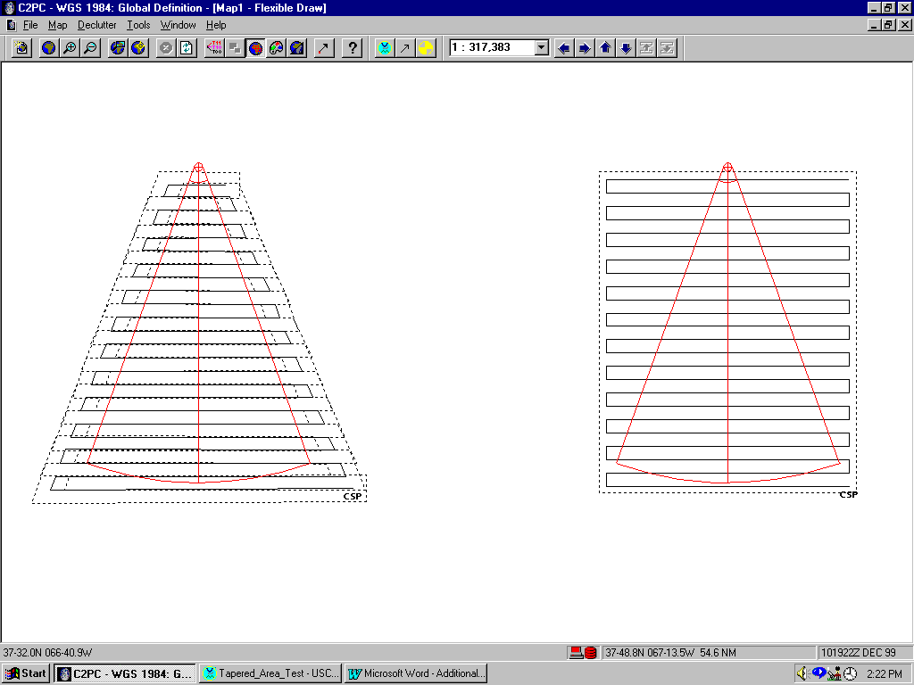
The illustration below shows search plans for two identical parachute flare reports. Both patterns use the same track spacing (0.8 for NVG equipped helicopter). The search pattern on the left covers 278 trackline miles and requires 2.7 hours to complete at 120 knots. The search on the right covers 370 trackline miles and requires 4.7 hours to complete.
USCG SAR TOOLS does not have the capability of plotting a tapered creeping line or parallel search. The tapered search above can be developed using the trackline search plotter. Although plotting the search becomes time consuming, the resource hours saved usually makes it worth it.

First Light Searches for Unresolved Flare Sightings
Section 2.F.3. of the Coast Guard Addendum requires a first light search for unresolved (insufficient information to either close or suspend) red or orange flares. This requirement does not imply ALL flare cases require a first light search that fail to locate the search objective. If aggressive nighttime searches were completed without sightings, and no correlating SAR (uncorrelated mayday call within the geographic area, overdue cases, EPIRB/ELT alerts, other flare sightings in the area) exists, search suspension should be considered. Aggressive nighttime searches involve total saturation of a confined area or a NVG search with a coverage factor greater than 1.0 for an appropriate search object. When there is the slightest bit of doubt, the SMC should plan for a first light search. The approach should be “why should I not have to plan a first light search?” Not “why should I conduct a first light search?”.
Planning a First Light Search
The same unknown variables associated with the initial nighttime search further complicate search planning for the first light search. Decisions on search objective, how to develop the new search area, sweep width and track spacing need to be readdressed and balanced with the amount of available resources.
Good search planning requires you to consider the effects of drift from the time of the report to the time the first light search commences. Unless the origin of the flare is at anchor, there is a chance that it drifted out of the original nighttime search area. Therefore, you need to account for the possibility that the search objective is still at anchor and the possibility that it drifted into a new area. You should also reevaluate the results of the initial search with any new information obtained, to help make logical assumptions when developing a first light search plan.
One way to develop a drifted search area for a first light search is to drift the “leeward” side of the flare plot. This drifted side then represents the far side of the new area. When computing the datum for the drifted line, you should drift a light displacement/no drogue vessel. This will account for both a 15-25 foot vessel and a 4-person raft.
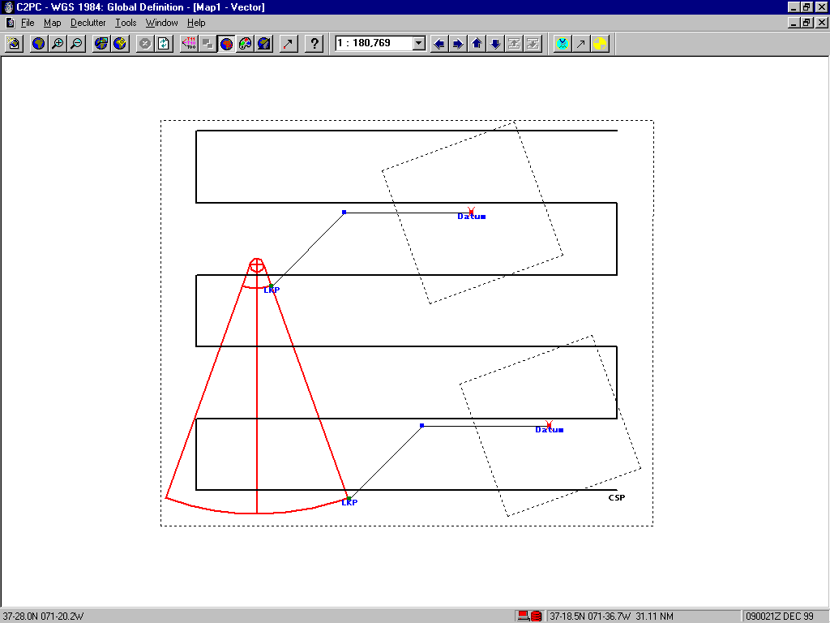
The illustration below depicts a drifted search area for a first light search using a track spacing for a 4-person life raft. In this case, the total water current and leeway would move the search object to the northeast. The drifted search area was developed by drifting the leeward side of the flare cone’s minimum and maximum range points, and includes the original search area.
Just as the case with the initial nighttime search, you must balance the track spacing assigned with the amount of available effort, the circumstances of the case, and the size of the drifted area. Under the right circumstances, the first light search area for a parachute flare seen the night before can be twice that of the initial search.
In absence of any other correlating information, your first light search’s objective should be a 20-foot powerboat in the coastal environment or a 4-person life raft in the oceanic. As mentioned before, these objects represent a most probable worse case scenario for their environments. The track spacing assigned and coverage factor obtained should be proportional with the degree of apprehension with the case. The coverage factor should reflect the amount of concern that a distress situation exists. The higher your apprehension, the harder you need to try to obtain a coverage factor of 1.0 or better.

Not only is it important for you as the SMC to remain motivated during a flare case, you need to make sure the SRU crews remain motivated as well. The high number of unresolved flare cases lead to complacency.

Operations
As SMC, you are the team leader. If the team senses your doubts about the validity of the flare report, they will likely perform a sub standard search. If they see you simply going through the motions, they will likely do the same. But when they see you taking the search seriously, they will likely do the same. Set the example through your own actions and approach to the case.
All members of the crew should be reminded of the importance of their jobs. Keep the lines of communications open and seek feedback on search results and weather conditions. Make sure they know they are not underway to simply check off a box on the check sheet. Keep a close eye on crew fatigue limits, and plan ahead when a fresh crew is needed for a first light search.
Appropriate Resources
Some SMCs believe a helicopter is required for all first light searches. This is not true. Surface units, including Coast Guard Auxiliary Facilities, can be used to conduct search light searches when available. Keep in mind, however, that a drifted search area offshore may become so large that airborne resources are required to complete a timely search.

Mission Conclusion is the final stage of a SAR incident. Usually, the same challenges and uncertainties experienced throughout the case cumulate one last time as you seek case resolution.

Mission Conclusion
Mission Suspension
Most flare searches require you to make several assumptions in order to develop a search plan. During the Mission Conclusion stage, you should review those assumptions and decisions to make sure they were prudent and reasonable. You should go back and review the information gathered from the reporting source and the results of the searches. Your review should ensure the following:
- All assigned areas were searched;
- PRE and EXCOM searches, if conducted, were completed;
- Cumulative Probability of Detection is as high as possible;
- Compensations were made for weather conditions and any other difficulties encountered during the search.
You should also make a final review of any other unresolved or pending cases, including:
- Uncorrelated mayday calls;
- Overdue or unreported cases;
- EPIRB or ELT alerts;
- Any other flare sightings.
If any new clues or information develop, you should consider reopening the case.

Case Closed
If your search locates a distressed or disabled vessel in the search area, you should confirm with the people on board that they fired the same flares that launched the search. If they did not launch the flare, then you probably have another case going on. If you can confirm the located vessel fired the flare, the case can be closed.

Flare case prosecution is both challenging and frustrating. The greatest challenge for the SMC is to develop the clues that will allow him or her to develop an obtainable search area that can be searched with a reasonable Probability of Detection.

Summary
The type of flare and height observed have a direct bearing on the search area size. A wild guess or swag on the part of the reporting source can produce an extensive search area. You should do everything in your power to accurately determine what was seen and use the appropriate error factors that reflects your confidence in the report.
The success of the search will be based, in part, on your abilities to communicate with the reporting source. Good interviewing skills and patience with inexperienced callers is paramount. Experience with flares, and a good understanding of occurrences that often are reported to be flares is important too.

References:

